HOW TO: BECOME AN ASCE NATIONAL MEMBER
Follow this step by step procedure to help you become a National Student Member of ASCE. It’s FREE.

- Visit this website: https://www.asce.org/membership/student/

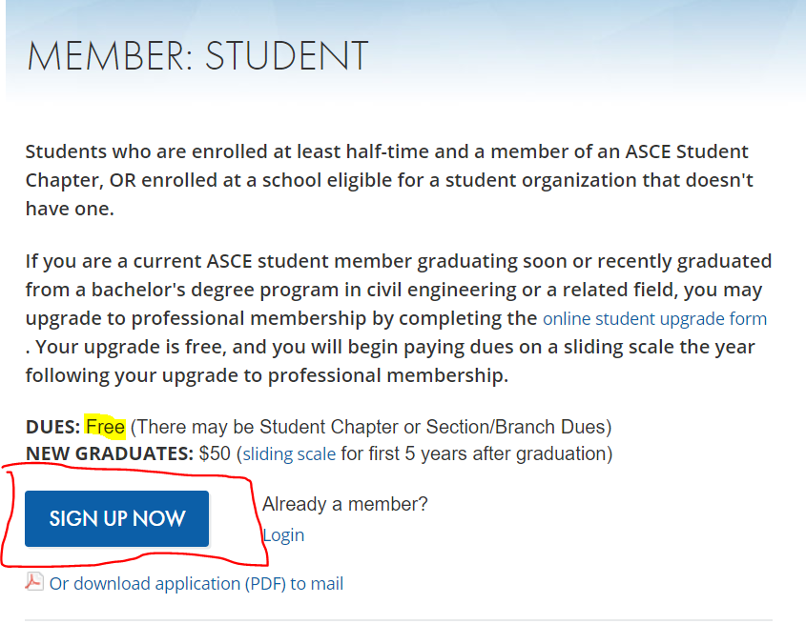
  - The two things you should see on the screen are these: 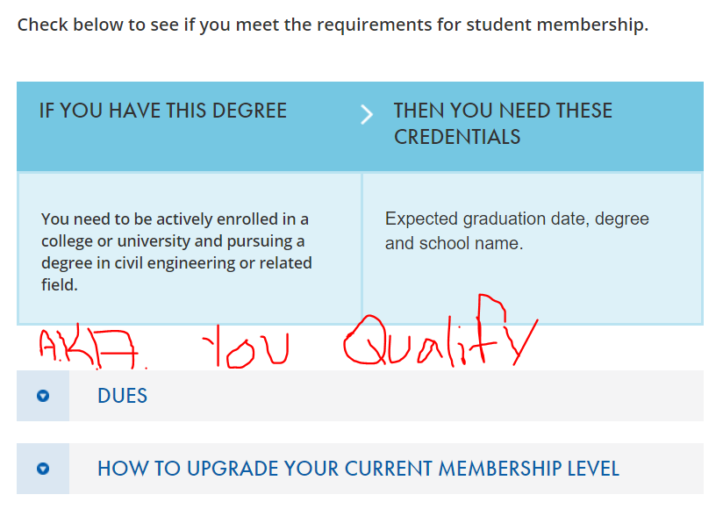
  - Click SIGN UP NOW

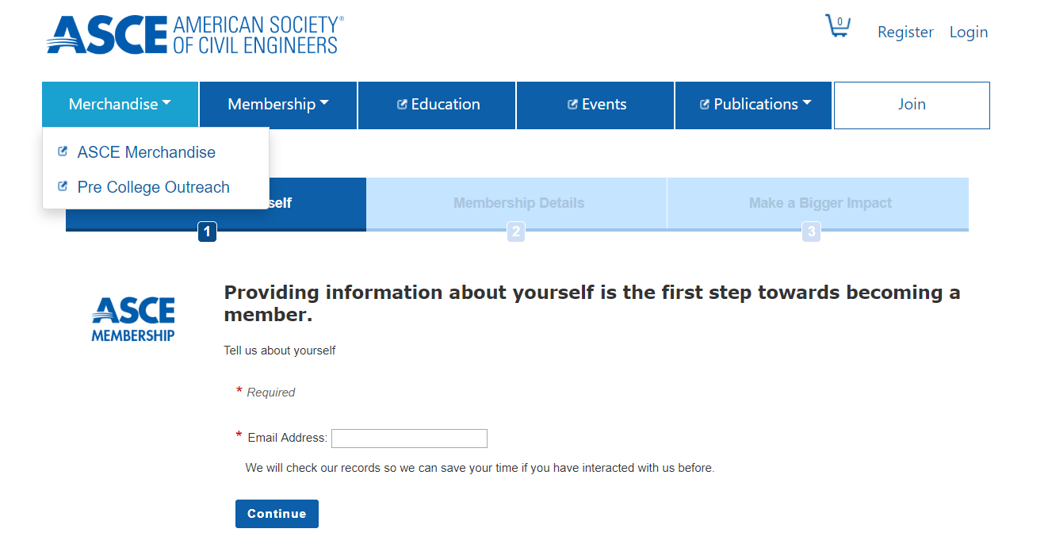
- It’ll bring you to this:
  - Fill in YOUR email address. (@ufl.edu) then hit CONTINUE
    - If there is already an account for that email it will tell you that after you hit enter. CONGRATS! You’re probably already a member

- Once you proceed to the next screen you need to fill in ALL spots that have an asterisk (*) next to them. Then hit NEXT.
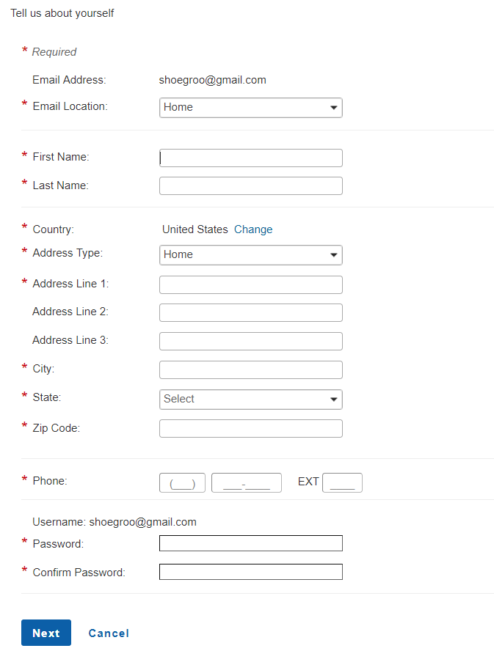

- Now, fill in your DEMOGRAPHICS, EDUCATIONAL BACKGROUND, and anything else like licenses or other attachments like resumes. Then hit NEXT.
  - 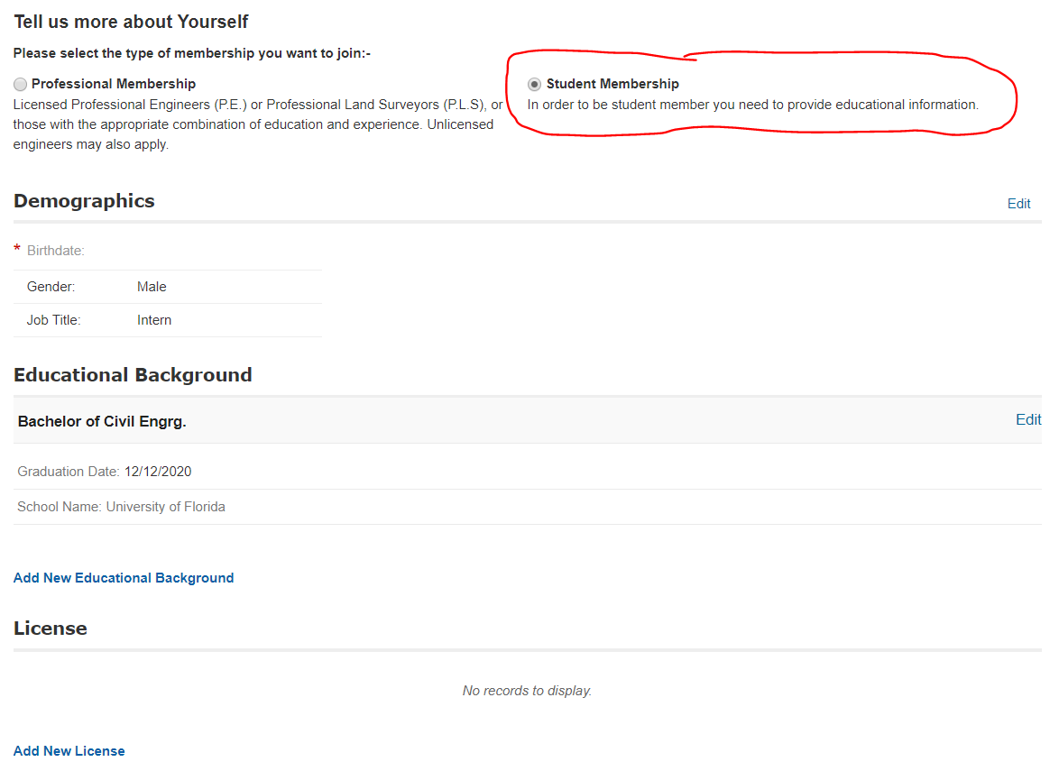
- Now choose if you’d like to join a section/branch. It automatically chooses one so make sure to select NO SELECTION SELECTED to be free!!! Hit NEXT.
  - 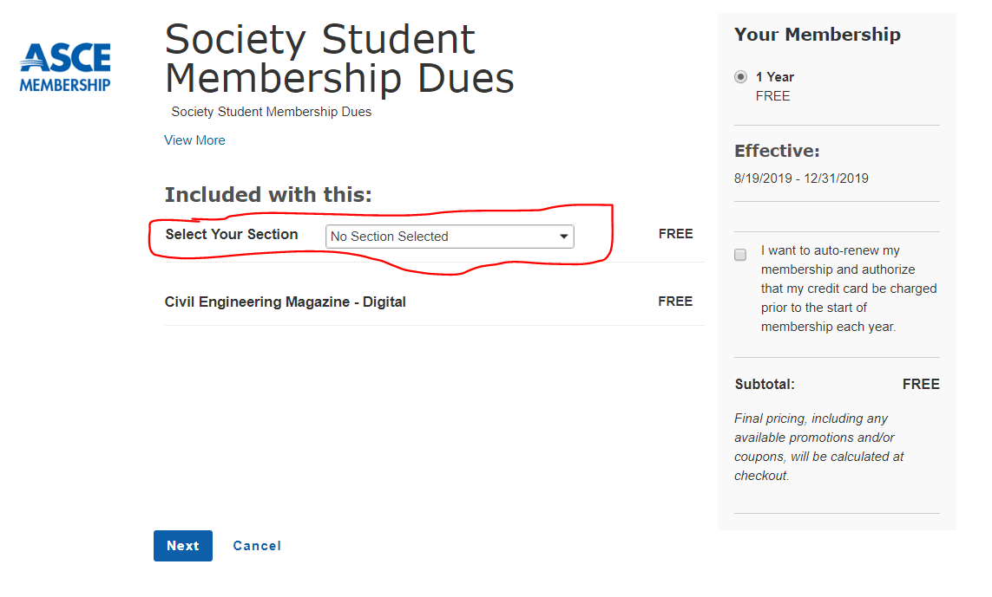

- Choose your institutes. It says the first is free, but I don’t know if that’s fake news or not. Go ham if it is. Click SIGN ME UP
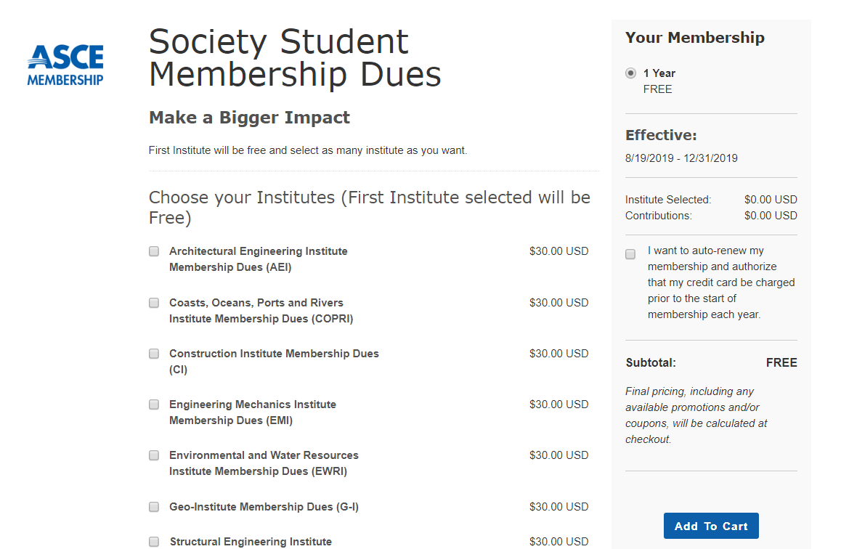

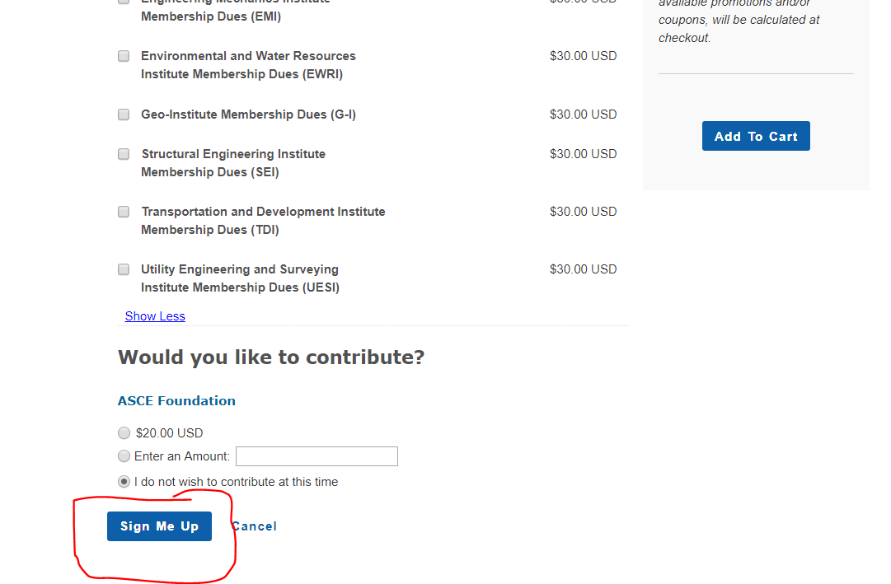

- YOU’RE ALMOST DONE!!!! Click SUBMIT.
  - 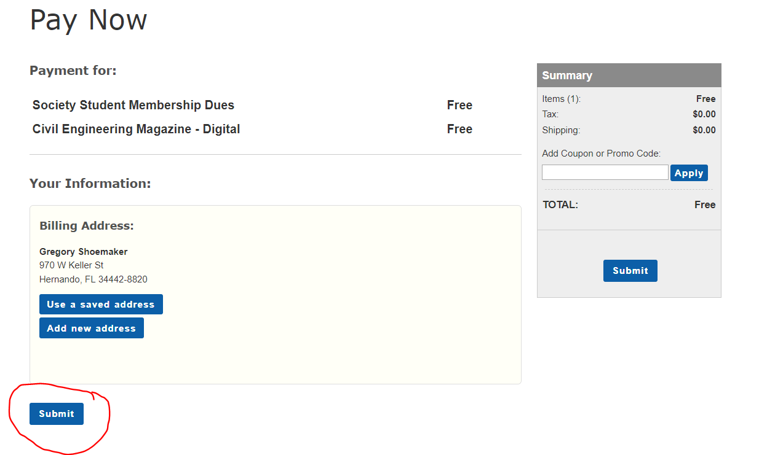

- Congratulations! You are now a member of the American Society of Civil Engineers. Thanks for joining!

